**AT&T Section**

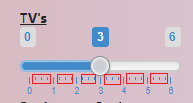

Can you get rid of those little dashes in between the main numbers on this section and on the Internet Options section.



Can this section be Check Boxes. You can have multiple premium options, so we want the ability to check all of them or none of them to add the pricing to the total amount.

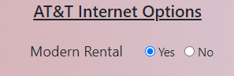

This should read Modem Rental not Modern Rental

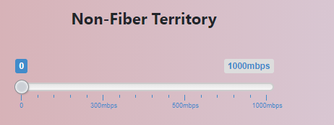

For the Non-Fiber Territory, the speed options should be… (also when I drag the bar the pricing doesn’t show up in the summary section)

25mbps

50mbps

75mbps

100mbps

Here is the pricing list for that too…

|  |  |  |
| --- | --- | --- |
| **Non - Fiber Territory** | | **Installation Fee** |
| 25mbps | $45.00 | $99 |
| 50mbps | $45.00 | $99 |
| 75mbps | $45.00 | $99 |
| 100mbps | $45.00 | $99 |

When none of the internet options are selected there should not be a price or mbps showing up. But when I have it set to 0 its still showing 300mbps for $35

